UNIT-II
1.List the JDBC Driver types?
A. Type 1 Driver : JDBC-ODBC Bridge.
Type 2 Driver : Native-API Driver (Partly Java driver).
Type 3 Driver : Network-Protocol Driver(Pure Java driver for database Middleware).
Type 4 Driver : Native-Protocol Driver(Pure Java driver directly connected to database).

2.JDBC Stands for_Java Database connectivity________________
3.What is the difference between JDBC and ODBC?
A. ODBC JDBC
1.ODBC Stands for Open 1. JDBC Stands for java database
Database Connectivity. Connectivity.
2 Introduced by Microsoft 2.Introduced by SUN Micro Systems
in 1992. in 1997
3.We can use ODBC for any 3.We can use JDBC only for Java
languages like C,C++,Java languages.
Etc.
4.For Java applications it 4.For Java application it is highly
is not recommended to use recommended to use JDBC because
ODBC because performance there we no performance & platform
will be down due to internal dependent problem.
conversion and applications
will become platform Dependent.
5.5.ODBC is procedural. 5.JDBC is object oriented.
4.What is JDBC?
A.JDBC is an application program interface (API) specification for connecting programs written in Java to the data in popular databases
5.What is database schema?
A.Database Schema refers to the overall structure of a database.
6.What is JDBC API and list some classes?
A.JDBC API defines the Java interfaces and classes that programmers used to connect to databases and send queries.
Some classes are DriverManager ,Connection ,Statement, PreparedStatement,CallableStatement, ResultSet
7.Why JDBC Driver is required in JDBC Connection?
A.That are available and handles establishing a connection between a database and the appropriate driver.
8.Write the use of Driver Manager?
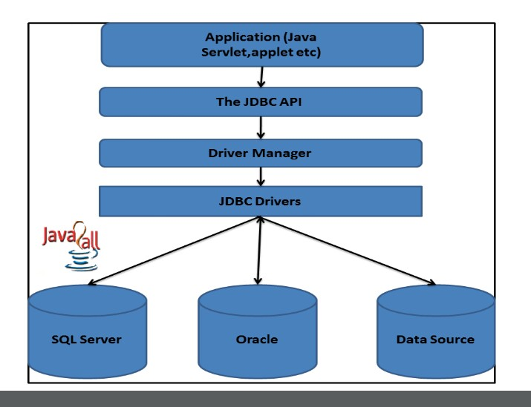
A.The DriverManager acts as an interface between user and drivers. 9.Draw the JDBC Architecture?
A.

10.Write the packages of JDBC API?
A. Java.sql and javax.sql
11.Which method is used to load the Driver?
A. Class.forName()
12.Which method is used to create a Statement Object?
A. Statement stmt=con.createStatement()
13.How many arguments a getConnection method takes and what are they?
A. 3 arguments they are url,username and password.
14.What are methods used to execute SQL queries in JDBC program?
A. executeQuery() is used for SELECT statement.
executeUpdate() is used for create, alter or drop table.
execute() is used when multiple results may be returned
15.ClassNotFoundException was generated by.........Ans.Class.forName()-------------
16.getConnection() method generates ----Ans.Sql--------------Exception?
17.Which method returns Resultset object?
A. ExecuteQuery()
18.How data is organized in Resultset Object?
A. In the form of rows and columns.
19.What is metadata?
A. Metadata is data about data.
20.In--Ans.Scrollable-------ResultSet, the cursor can scroll forwards and backwards, and the result set is not sensitive to changes made by others to the database that occur after the result set was created.?
21. Which method is used to establish the connection with the specified url in a Driver Manager class?
A. getConnection()
22.Which indicates a result set that cannot be updated programmatically in concurrency?
A. CONCUR_READ_ONLY
23.Which kind of driver converts JDBC calls into calls on the client API for Oracle, Sybase, Informix, IBM DB2, or other DBMS?
A.Native ApI drive
24.Which is used to call the stored procedures and functions?
A. CallableStatement()
25.Which method is used for an SQL statement that is executed frequently?
A. ExecuteUpdate()
26.How many steps are used to connect any java application using JDBC?
A. 5 steps
27. Which JDBC driver is known as fully java driver?
A. Type 4 driver-Native protocol driver.
28.Which driver uses ODBC driver to connect to the database?
A. Type 1 driver-JDBC to ODBC bridge.

UNIT-III

ONE Mark Questions
1.Define Servlet.
A.It is a java program that runs on the server.
2.What are servlet life cycle methods?
A. Init()
Serivice()
Destroy()
3.What are the ways to create a servlet?
A. (i) By inheriting the GenricServlet class
(ii) By inheriting to http servley
4.What is the jar file required to compile the servlet java program?
A. servlet-api.jar
5.What is a web server?
A.web server is a software program that is used to host websites.
6.What is the name of xml file required to run the servlet?
A. web.xml(deployment descriptor)
7.What is the default port number of apache tomcat web server?
A.8080
8.What is Servlet Config object?
A.It is used to initialize parameters and to retrive data stored in web.xml file
ServletConfig config=getServletConfig();
9.What is destroy () method?
A.It is the last phase of servlet life cycle that when executed destorys a servlet.
10.Write the syntax of doGet() method in HttpServlet class?
A. public void doGet(HttpServletRequest req,HttpServletResponse res)
11.What is the purpose of <url-pattern> tag?
A.It is used in servlet mapping to uniquely identify the specified servlet from action attribute.
12.What is different tomcat Components?
A. Catalina (a Servlet container)
Coyote (an HTTP connector)
Jasper
Cluster
High availability
13.Which tomcat component is used to process servlet?
A. Catalina
14.Write the differences between static vs dynamic website?
A. Static website cannot interact with database whereas dynamic website can interact with database.
15.Name web servers available today?
A. Tomcat,glass fish etc..
16.Write the use of HTTP Protocol?
A. To transfer the data through internet.
17.Write the job of servlet?
A. To make a website as dynamic website,it is used as a middleware when user interact with database.it contains jdbc code.
18.Write the differences between CGI Vs Servlet?
A. In CGI a new process is started for each HTTP request where as with servlets, the Java Virtual Machine stays running and handles each request using a lightweight Java thread
If there are N simultaneous requests to the same CGI program, the code for the CGI program is loaded into memory N times.
With Servlets however, there would be N threads but only a single copy of the servlet class
19.Draw the directory structure of servlet?
A.
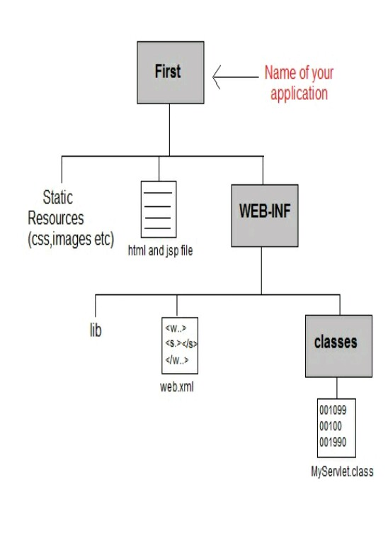

20.Which method is used to retrieve data from HTML form element
A.getParameter(String name)
21.When doPost() method of servlet gets called?
A. When Post method is specified in html page.
22.Which method can be used to get the multiple values of a parameter like checkbox data?
A.getParameterValues()
23.Servlets handle multiple simultaneous requests by using threads(True/False).?
A.True
24. Which packages represent interfaces and classes for servlet API?
A. javax.servlet,javax.servlet.http
25.Which servlet can handle any type of request so that it is protocol-independent?
A.GenericServlet

